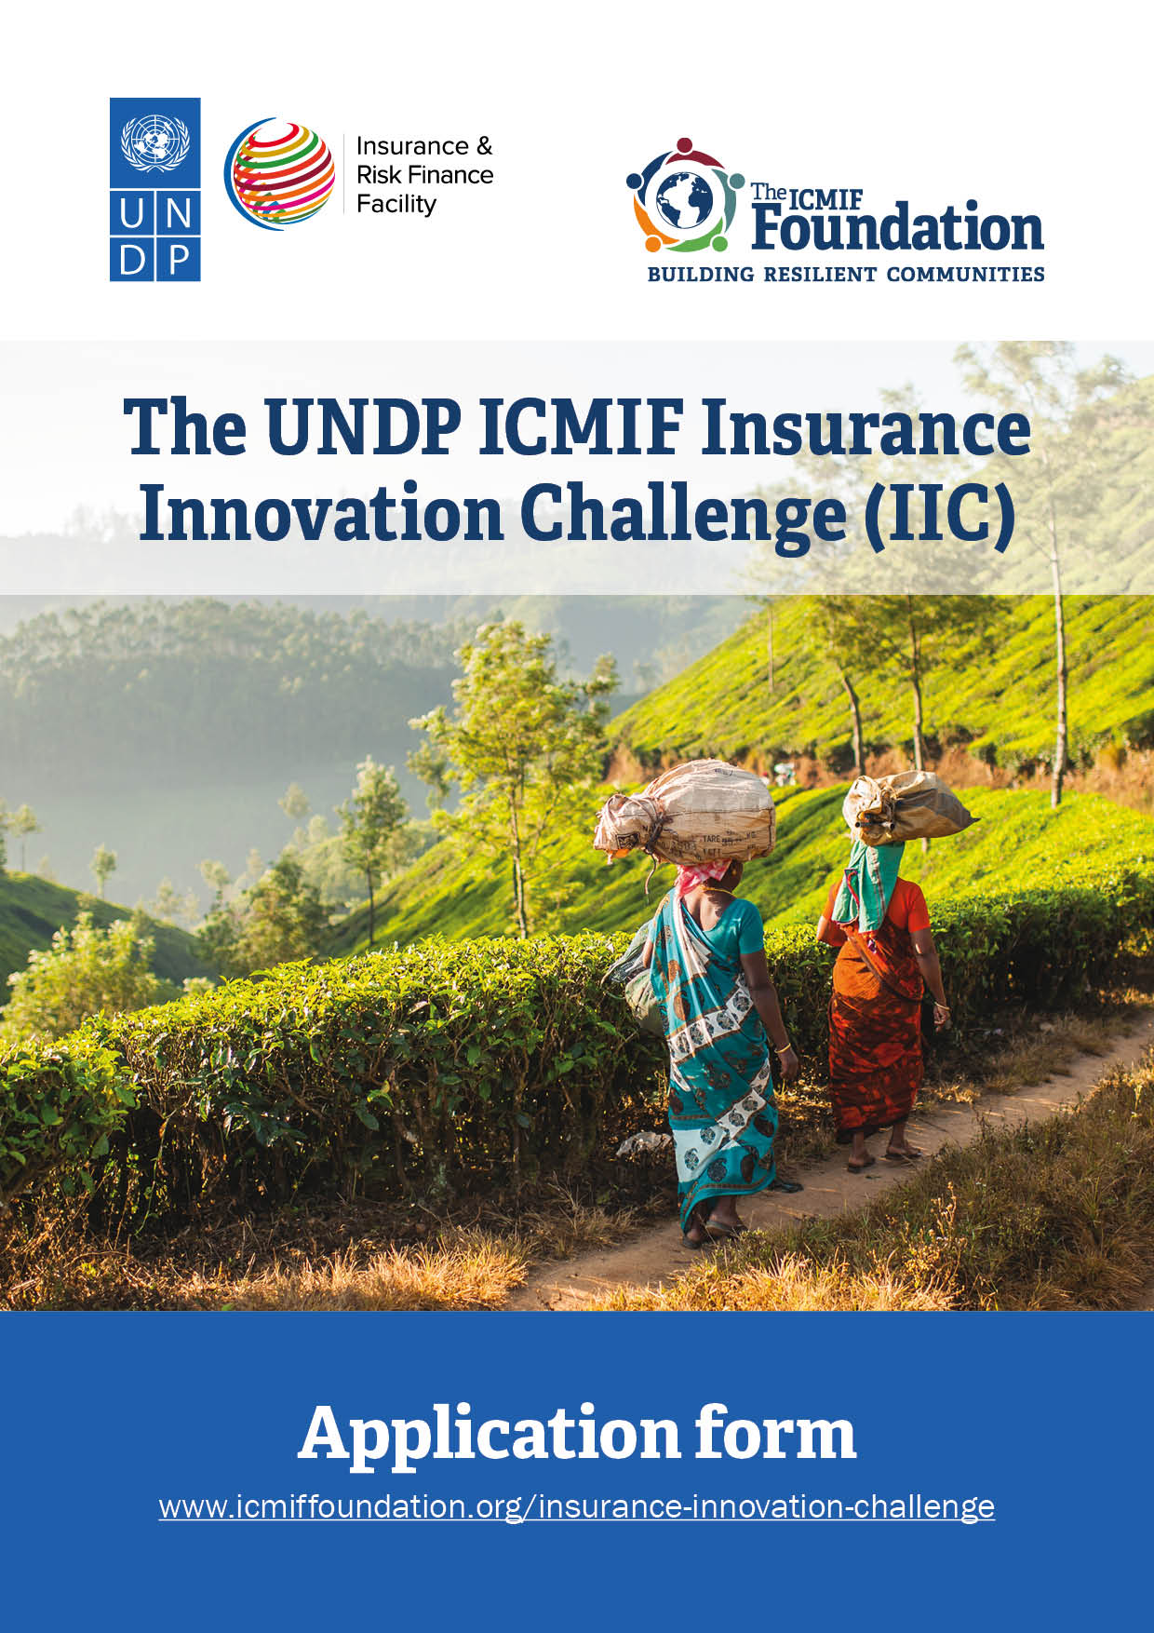

Instructions
- Applications should be submitted using the application form and templates provided. Applications submitted in a different format will not be considered.
- Before completing the application form, please read the Call for applications and Guidelines for applicants carefully.
- Please complete all sections of the application form in English using Arial font size 11.
- Follow the guidelines provided in grey with each question. Note: These should be deleted before submitting the Application Form. The cover page and instructions should also be deleted.
- Applications that exceed the maximum number of pages (12 pages excluding attachments) will not be considered.
- All required documents and annexes must be submitted together with a signed application form before the deadline. Documents submitted after the deadline or incomplete applications will not be considered; All questions are mandatory.
- Once completed, submit your signed application form via email to foundation@icmif.org, together with all the annexes and supporting documents (See list below). Please include “IIC” and the name of the applicant in the subject line.
- Attachments are to be submitted in an electronic format (PDF, Word, Excel). Hard copies may be requested at a later stage.
- Please ensure that the total size of the email and attachments does not exceed 10 MB. The International Cooperative and Mutual Insurance Federation (ICMIF) Foundation will not be responsible for any application emails that fail to be sent/received.
- The deadline for submissions of applications is 28 April 2023 at 12:00 pm (BST).
- Submissions received after the deadline will not be considered. Please note that all submissions will be time-stamped. You will receive an email confirmation of the receipt of your application.
- Each entity may submit more than one application but only one application per entity can be approved. Re-submission of a modified or improved application after the deadline is not allowed.
- Please contact us by email at foundation@icmif.org for any problems or questions, we will do our best to reply in a timely manner. Please include “IIC” and the name of the applicant in the subject line. The ICMIF Foundation will consider incoming questions until 26 April 2023 at 12:00 pm (BST).
- Check the UNDP ICMIF Insurance Innovation Challenge (IIC) webpage for updates and announcements: https://icmiffoundation.org/insurance-innovation-challenge/
- The Frequently Asked Questions (FAQ) section will be compiled after the online information session.
- The IIC project team will host an online information session on the IIC on Monday 20 March 2023 at 09.00 GMT (click to register).

Attachments to include with the application
- Application form with signed “ACCEPTANCE OF TERMS AND CONDITIONS”
- Extract from Public Registry or relevant registration documents for your organisation issued by the appropriate authority (e.g., incorporation certificate). This may differ depending on the type of entity applying. The IIC Project Team may request additional documentation.
- ANNEX 1 – Signed declaration to confirm the applicant is not included in the UNDP Vendor Sanctions List. This will be required for all members of a consortium or joint venture, if applicable.
- ANNEX 2 - Budget template (Excel sheet)
- ANNEX 3 – Summary audited financial performance for the last three years (Excel sheet, PDF or Word document)
- ANNEX 4 – Copy of insurance product policy
- ANNEX 5 - CVs of team members (PDF or Word)
- ANNEX 6 – Summary information of your existing inclusive insurance business. Key metrics over the last three years including, specifically, the product proposed to be scaled up.

Applicants may be asked to submit additional documents during the initial screening phase.
Insurance Innovation Challenge
(IIC)
APPLICATION FORM

Applicant INFORMATION
NAME OF APPLICANT (The legal Entity) | Type here
Address | (Street, city, state/province, postal code) |  | Telephone | Type here
 |  |  | Website | Type here
TYPE OF Entity &  & LEGAL FORM  (eg cooperative, mutual, corporation) | Type here |  | Legal registration number | Type here
country OF REGISTRATION | Type here |  | year of registration | Type here
Name & TITLE of Contact Person  Individual submitting proposal on behalf of the organisation | Type here |  | Telephone | Type here
 |  |  | E-mail | Type here
is this an application with a co-partner/s? | ☐ YES  ☐ No | LIST all members of the partnership (if applicable) | Click or tap here to enter text.
Provide a brief description of your organisation
Type here (max. 300 words)

[GUIDELINES: LEAD APPLICANT & PARTNER]
- Please include history, type of organisation, mission, objectives, values/ social ethos, date of incorporation/ registration, number of employees, industry awards and financial performance for the last three years. (Please attach financial statements and other information annex 2).
- Please include connections with the underserved communities in your country.
- Please include information on what portion of total insurance business is devoted to inclusive insurance; a description of services/products provided; date started; geographic coverage; and outreach. (Please attach more detailed information regarding current inclusive insurance business as Annex 6)
- Please provide information on any donor support you have received in the last five years

Type here

Please provide two references from external organisations/individuals involved in your inclusive insurance projects.

Project overview
PROJECT TITLE |  |  | Click or tap here to enter text.
TIME FRAME FOR IMPLEMENTATION  [MAX 24 months/ 2 years) |  |  | (Earliest start date) |  | (Latest completion date)
Project Location |  |  | Country name |  | State/Province
Target CLIENTS/BENEFICIARIES: |  |  | Type/Number/Gender
Target no. of policyholders | Click or tap here to enter text. | No. of family members covered by policy |  | Click or tap here to enter text. | Total coverage | Click or tap here to enter text.
Type here (max. 500 words)
[GUIDELINES:
- Describe the target clients? What is their socio-economic profile? What is their average income level? What economic sector/s do they belong to?
- How many are women?
- How will the target clients be engaged?

Project description – Proposed solution
Type here (max. 500 words)

[GUIDELINES:
- Problem analysis: Describe the problems/issues your organisation faces in expanding inclusive insurance coverage? What is hindering uptake? What seem to be the root causes?

- Describe the proposed solution and the expected outcomes of the project. Please include measurable and verifiable indicators of the outcomes with reference to the project starting point.]

The proposed solution should include:
- Description of the product for scaling up (please attach insurance policy as
Annex 3)
- How affordable is the product – how much is the premium? Is it paid in a lump sum or instalment? If by instalment, how much will the client pay per instalment? How many average days’ earning of the target clients is the premium?
- How appropriate is the product – What are the key features that address the needs of the target clients? What risks does it cover? Is it optional or mandatory? how many people are covered by the policy?
- Description of the marketing, distribution system and enrolment process
- How will clients be made aware of the product?
- How will the products be distributed? What distribution channels will be used? How accessible are these channels and collection points to the clients?
- What is the client enrolment system? How easy is it for the clients? What papers are required from the client?
- Description of any new technology, systems or process to be employed
- What new technologies are planned to be used?
- How will it improve the delivery of programme objectives and create scale?

project BUDGET Summary
Please provide detailed budget breakdown in a separate excel sheet in Annex 4. Budget should be itemised as per activity plan.
AWARD requested (USD)  [Up to USD 100,000.00] | USD ___.__ | (__%)
Co-Funding provided by the proponent (USD)  [Applicant’s in-kind or cash contribution to the total project costs] | USD ___.__ | (__%)
Total BUDGET (USD) | USD ___.__ | (100%)

degree of innovation
Type here (max. 250 words)

[GUIDELINES: Describe what makes the proposal innovative:
How different is the approach from traditional insurance and/or from other inclusive insurance providers? What is different? What makes it unique? (Is it the product? The marketing and delivery channels? The enrolment, claims and other processes? The use of financial technology? etc)]

Scale up & Replication
Type here (max. 300 words)

[GUIDELINES: What is the feasibility of scaling-up and replicating your solution?]
- Is the proposed scaling-up/expansion realistic?
- Is the approach financially feasible? Is it cost efficient? Will income be able to cover expenses after the support period? Can the product be offered to the target clients at an acceptable price point?
- Is the approach technically feasible? Are the systems, processes and technologies in place or available? Does it work?
- Potential to replicate the project – how easy is it to replicate in other regions in-country?

Development Impact (Social, Economic, Environmental)

Type here (max. 250 words)

[GUIDELINES: Describe how the proposed solution can help overcome development challenges in developing countries and contribute to the achievement of the United Nations (UN) Sustainable Development Goals (SDGs) and targets. In addition, please describe how the solution will increase the resilience of the target households.]

Gender
Type here (max. 300 words)

[GUIDELINES: Briefly describe how your solution will support gender mainstreaming, including benefits to women and girls, either directly or indirectly]

FINANCIAL sustainability
Type here (max. 250 words)

[GUIDELINES: Briefly describe how the solution will be sustained once the IIC support comes to an end.]

- How will long-term financial sustainability of the proposed solution be ensured?
- When do you expect the proposed solution to be financially self-sustaining?

project management capability
Type here (max. 200 words)

[GUIDELINES: Briefly describe how the project will be managed.
- Explain why your team is uniquely qualified to implement the proposed solution.

- Provide evidence of your organisation’s relevant expertise (previous experience in managing similar projects and/or results of your current inclusive insurance programme). Include an Annex 6 if needed.]

roles and responsibilities
[GUIDELINES: Balance between women and men in the project team(s) responsible for implementing and publicly presenting the project.]
Team Member’s NAME | Role & Responsibilities | GEnder
Please attach CVs of all relevant team members as an Annex 5.

Project Plan
[GUIDELINES: Please describe the expected outcomes and the planned activities per outcome for the proposed solution and the proposed timeline.]

Description of outcomes and activities per outcome |  | Q1 | Q2 | Q3 | Q4 | Q5 | Q6 | Q7 | Q8
Outcome 1 | Type here
Activity 1 | Type here
Activity 2 | Type here
Activity 3 | Type here
Outcome 2 | Type here
Activity 1 | Type here
Activity 2 | Type here
Activity 3 | Type here
Outcome 3 | Type here
Activity 1 | Type here
Activity 2 | Type here
Activity 3 | Type here
Please add rows if needed.

RISK ASSESMENT
[GUIDELINES: Identify high-level external risks and propose strategies to mitigate them.]
RISK | Mitigation Strategy

All information disclosed in submitted applications will be treated in strict accordance with UN personal data protection and privacy principles: Personal Data Protection and Privacy | United Nations - CEB (unsceb.org)

Acceptance of terms and conditions
By signing this form, the applicant accepts the following terms and conditions:
The applicant declares that he/she is bounded by the process and rules of the competition that were specified in the Guidelines of the UNDP ICMIF lnsurance Innovation Challenge (IIC) and shall accept the outcome of the process without any deviation or reservation.
The applicant shall bear all costs related to the preparation and submission of the proposal regardless of whether his/her proposal is selected or not. He/she accepts that The ICMIF Foundation and UNDP will in no case be held responsible or liable for those costs regardless of the outcome of the process.
The applicant accepts that The IIC Project Team determines the level of responsiveness to the call for proposals of the UNDP ICMIF lnsurance Innovation Challenge (IIC) exclusively on the contents of the written, submitted, and signed Application Forms and Annexes.
The applicant accepts that information relating to the examination and evaluation of the applications, and selection of awardees and signature of award agreement shall not be disclosed to any person not officially concerned with such processes.

Signature: …………………………………………………
Name: …………………………………………………
Position: …………………………………………………
Date: …………………………………………………

Annex 1

DECLARATION

Date:

United Nations Development Programme
Bureau for Programme and Policy Support
304 E. 45th St. 9th floor
NY, NY 10017 USA

Assignment: UNDP ICMIF Insurance Innovation Challenge (IIC)

Reference: IIC 2023

Dear Madam/Sir,

I declare that …………………………………………………………………. is not in the UN Security Council 1267/1989 List, UN Procurement Division List or Other UN Ineligibility List. Yours Sincerely,

Signature: …………………………………………………
Name: …………………………………………………
Date: …………………………………………………

